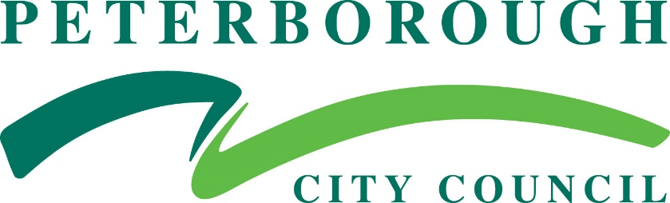

Job Description

Department: | Place and Economy
Division/Section: | Development & Construction
Job Title: | Senior Development Management Officer
Post No: | 6183, 6186,10394
Grade: | 11
Reports to: | Majors Manager – Development Management
Organisation Chart:  Show immediate manager and any jobs reporting to this post. | DM OFFICERS X 5  SENIOR DM OFFICERS X3  PRINCIPAL DM OFFICERS x 5  DM MANAGERS X2  HEAD of PLANNING
CRB Check applicable? | Standard Enhanced None
Is post exempt under the Rehabilitation of Offenders Act
1974 in respect of declaration of spent convictions?
Yes No
Line Management responsibility for: | No. of direct reports: 0  No. of indirect reports: 0
Size of budget: | None
Job Purpose: | Deliver high quality services through achieving customer satisfaction levels in line with national standards, effectively engaging with internal and external customers to inform and advise and when required, project manage major applications or account manage a range of minor applications, in line with best practice, national standards, organisational requirements and statutory obligations.

Main Duties and Responsibilities:
  - Effectively engage with residents, businesses, developers, partners, Council staff and elected members at all stages of the planning process and other forms of applications, to ensure that recommendations, advice and other actions comply with the Council’s Planning Policies the requirements of the Town and Country Planning Acts and/or associated Orders and Regulations.

  - Handle own case load of applications of moderate complexity with limited supervision and under the guidance of area managers.

  - Act as account manager for specified development types or planning issues; develop and share best practice and give guidance.

  - Participate in complex development projects, reporting to the project manager

  - Represent the service on cross functional and inter-authority teams, at Council committees and at public meetings, to ensure that accurate, up to date recommendations and advice are available and any required actions are delivered on time.

  - Coach and motivate individuals, share knowledge and develop best practice to ensure individual, team and relevant service objectives and targets are delivered.

  - Ensure that all correspondence is complete, up to date and effectively dealt with and recorded as part of the overall planning process and to be of a quality and transparency to inform appeals, enforcement action and the Council’s complaints procedure.

  - Participate in the regular review of service provision in line with national best practice and quality standards, including where required, participation in cross function teams, and implement any required improvements effectively to ensure the on-going efficient delivery of services.

  - Contribute to and initiate the review of new legislation, Directions, Planning Policy Statements, Circulars, recent court cases and research and make recommendations to the service and other relevant departments, of the potential impact and relevance to future service delivery.

  - Deliver excellent customer services in line with national standards and best practice, play an active role in the Development Management Team, effectively manage personal workload of projects, and identify and achieve personal development opportunities.

Generic Responsibilities: | To carry out all responsibilities with regard to the Council’s Equalities Policy and Procedures and Customer Care Policy.  To comply with all Health & Safety at work requirements as laid down by the employer.
Flexibility Clause: | Other duties and responsibilities express and implied which arise from the nature and character of the post within the department (or section) mentioned above or in a comparable post in any of the Organisation’s other sections or departments.
Variation Clause: | This is a description of the job as it is constituted at the date shown. It is the practice of this Authority to periodically examine job descriptions, update them and ensure that they relate to the job performed, or to incorporate any proposed changes. This procedure will be conducted by the appropriate manager in consultation with the post holder.  In these circumstances it will be the aim to reach agreement on reasonable changes, but if agreement is not possible the Head of Service reserves the right to make changes to your job description following consultation.
DATE: | January 2022 | COMPLETED BY: | Sylvia Bland

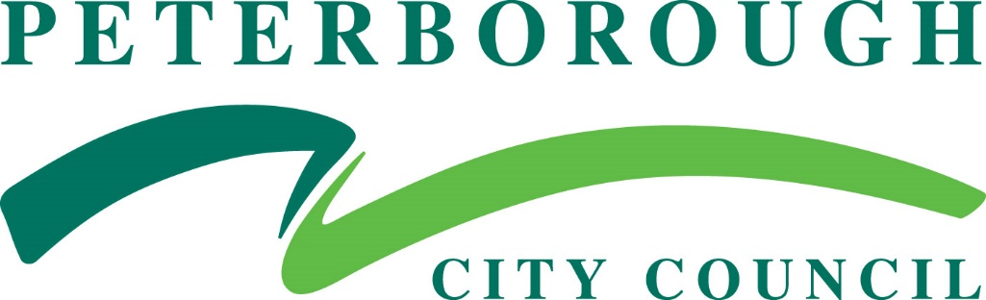

Person Specification
JOB TITLE: | Senior Development Management Officer | POST NO: | 6183, 6186,10394
GRADE: | 11 | DEPARTMENT: | Place & Economy
HOURS | Full Time
DIVISION: | Development and Construction | DIRECTOR: | Steve Cox
DATE: | January 2022 | COMPLETED BY: | Sylvia Bland

ATTRIBUTES | ESSENTIAL CRITERIA | DESIRABLE CRITERIA
KNOWLEDGE | - Current relevant planning legislation and regulation (A/I) | - Current legislation and regulation in other related areas (A/I)
SKILLS & ABILITIES | - Project management (A/I)  - Change management (A/I)  - Effective delivery of performance in line with local and national targets (A/I)  - Delivering high qualities services to both internal and external customers (A/I)  - Effective verbal and written communication skills (P)  - Ability to prioritise workloads and meet strict deadlines (W)  - Broad range of IT skills including Microsoft Office, Planning Systems e.g. Uniform (A/I) | - EDRMS/GIS systems use (A/I)  - Project Management tools and techniques in line with Prince 2 methodology (A/I)
EXPERIENCE | - 3 years broad experience of development delivery (A/I) | - Understanding of the political interface with elected members (A/I)  - Experience of delivering services in a major growth area and/or across multiple planning fields (A/I)
QUALIFICATIONS | - Degree or equivalent in town planning or related subject (A/D) | - Eligible for Membership of the RTPI (A/D)  - Additional qualification or expertise in a relevant specialised discipline (A/D)
PERSONAL CIRCUMSTANCES | - Full driving licence (D)  - Vehicle available for work (I)  - Ability to work flexibly including some evening meetings (I)
EQUALITY | Candidates must demonstrate understanding of, acceptance and commitment to the principals underlying equal opportunities. (A & I)
CUSTOMER CARE | Knowledge and understanding of effective customer care (A & I)

[ At the end of each criteria the following codes are used to indicate how the criteria will be assessed: (AI) Application / Interview, (P) Presentation, (W) Written Test.]

